**Address:**

Camelback Casita

3526 N. 63rd Place

Scottsdale, AZ 85251

Door code:

7197🔒

Owner:  
Devon Cramer

Wifi:

Camelback Casita

Pw: sunshine3526

[airbnb.com/h/thecamelbackcasita](http://airbnb.com/h/thecamelbackcasita)

8 guests · 4 bedrooms · 4 beds · 2 baths

House notes from Brindy visit:

* propane grill (need to stay on top of keeping propane full)
* Monday is trash day (black bin)
* Friday is recycling day (pink bin)
* Trash is on side of house
* Pool is serviced on Tuesday in the morning
* Every other Monday is landscaping, landscaper lets themselves in through gate
* Air pump (for bike tires), water softener, vacuum in laundry room
* We have 2x bikes!
* Pack n plays (there are 2! Plus bassinet attachment),, full size high chair in closet of first bedroom
* Lots of bakeware!

# Property Inspection Log:

**Date of Notes:** XX

**Next Inspection Scheduled:** XX

* Swap out guides so that Devon’s phone number is not listed

# Restock strategy:

* W&G?
* Any special items different to our standard?

# Guest Access

* **Access Code:**
  + **Schlage Smart Lock:** A unique code generated for each guest (access Smartlock in Hospitable “Devices”)
  + **Backup Key / Lock out strategy:**
    - XXX
* **Garage access:** 
  + xxx
* **Cleaning closet:**

# Wi-Fi Information

* **Network Name:** XX
* **Password:** XX
* **Notes:**
  + Internet provider
  + **Account Email:** XX
  + **Account Number:** XX

# 

# House Notes

**Water Softener** - when it regenerates it’s quite noisy. Doesn’t last long but guests say it sounds really loud and weird but it’s perfectly fine and normal.

**Pool Waterfall** - is on a timer. If guest wants it to come on and off at a specific time, let Devon know and she can adjust the time.

### Guest Guide

* XX
* **Guest Messaging Guide:** [Google Doc Link](https://docs.google.com/document/d/16qBEfvNvXssen6w8ewwPsNpatKLuUd0dn8dHKpjoDGA/edit)

### Good to know

* Ie: Where something is that is often misplaced by guests, how to work something that is often asked about

### Trash & Recycling:

* XX
* XX
* *Auto message is scheduled in Hospitable to send to guests ______ night to take out the trash

### 

### AC Filter Size & change frequency:

* XX

### Breaker Box:

* Breaker box is located ________

### 

### Mail:

* XX
* XX

### 

### Commonly asked about amenities:

* **Firepit:**
  + How to use: To use the fire pit, you'll need to: pull out the drawer, press and hold the igniter button, then while holding the button, use the lighter to ignite around the rock area. Let me know if that works for you!
  + 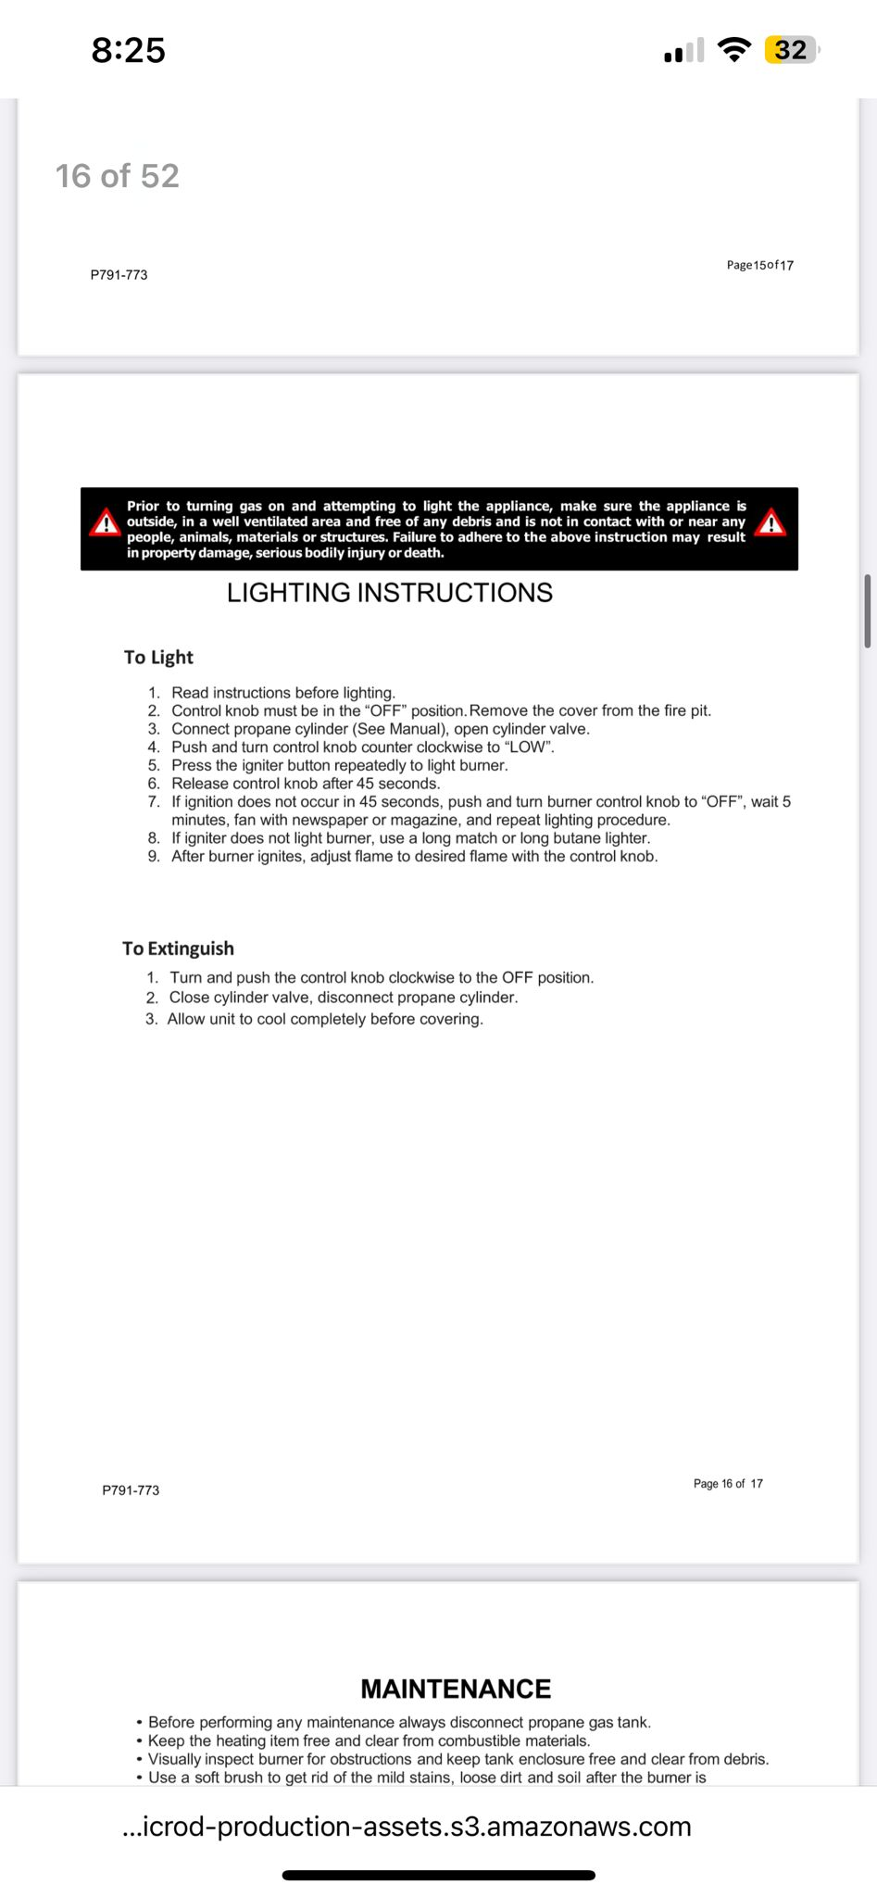
* **Grill:** Propane or charcoal?
* **Backyard:** Fully fenced? What amenities?
* **Pack n play:** Location. Sheets?
* **Coffee maker**: Type? Type of coffee provided?
* **TV:** Smart TV? What apps?

### Pet Policy:

* XX

# Smart Home Devices:

### 

### Thermostat:

* + **Device:** XX
  + **Login:** XX
  + **Password:** XX

### 

### Security Camera:

* **Location**
* **Access:**
  + Access on a phone/iPad app
  + Log in info:

# Cleaning:

* **Primary Cleaner:** XX
* **Scheduling:** XX
* **Extra Jobs:** XX

# Handyman / Maintenance:

* **XX**
  + XX
* **Landscaping:**
  + XX
* **Pest Control**
  + XX
* **HVAC**
  + XX
* **Plumbing**
  + XX

# 